Did you know........?
- Ears are designed to clean themselves. Wax in ears is normal (although excessive wax can result in problems).

- Ears need wax for lubrication and protection. Ear wax is acidic and has bacterial and fungicidal properties.

- Try to keep your ears dry. Static water left in the ear canal can lead to infection.

- Please do not use cotton buds (or any other implement) as it only pushes the wax further into the ear. This can make it more difficult to remove and can cause damage to the ear drum.

Care of your ears.

- In order to encourage the natural process of wax expulsion and prevent the build up of wax insert a single drop of olive oil into the affected ear on a weekly basis.

- Prior to a consultation for wax removal instil 2 or 3 drops of olive oil (at room temperature) twice a day for 5-7 days prior to the consultation.

- Do not leave cotton wool at the entrance of the ear. Apart from the risk of it getting stuck in the ear canal, it acts as a wick and soaks up the oil.

- You may find it easier to buy a “dropper” bottle from your local chemist and add some olive oil to the “dropper” bottle (the “dropper” bottle cost is relatively low)

Procedure to Instil Ear Drops

- Lie down on your side with the affected ear uppermost.

- Pull the pinna backwards and upwards (see diagram). Drop 2-3 drops of oil into the ear canal and massage the tragus (see diagram) just in front of the ear.

- Stay lying down for 5-10 minutes and then wipe away excess oil. Do not leave cotton wool at the entrance of the ear.

- Repeat the procedure with the opposite ear if necessary.
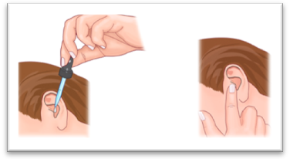

DON’T ignore your ear problem....

Please make an appointment with your GP if you have any ear problems, for example:

- You have recently found it difficult to hear the television or radio.

- You are missing words in conversations.

- You have recently developed sensitivity to sudden noises.

- You have dizziness or ringing in your ears.

- You have pain or a discharge coming from your ear.

EAR CARE

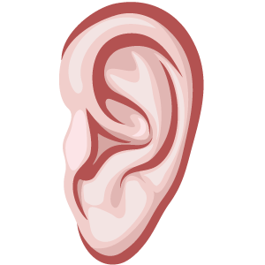

A Leaflet for patients

